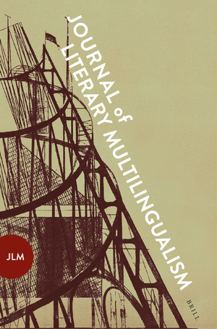 | Journal of Literary Multilingualism  ISSN: 2667-324X  Call for Papers  Special Issue:  Literary Multilingualism Studies: The Future of the Discipline

Literary multilingualism studies is a relatively new but burgeoning area of research. With the impact of the ‘transnational turn’ and translation studies within literary studies, and with the growing relevance of the ‘postmonolingual condition’ in the contemporary world, multilingual and translingual writing practices – considered in the past to be exceptional and unusual – are now at the forefront of literary studies.

Scholars in the field are drawn from a diverse range of linguistic, cultural, political, disciplinary and theoretical positions, engaging with literature of all periods and all parts of the world. This rich diversity, however, means that there is currently little consensus on established terminology and on how ‘literary multilingualism’ might be defined. in addition to this, scholarship is fragmented in the sense that scholars engaging in one field of the discipline are often unaware of work being done in others. There is thus a strong need for more dialogue.

For this inaugural issue of the Journal for Literary Multilingualism we invite scholars to engage in a dynamic assessment of the discipline and its future. We seek to gather together a range of responses and debates around the following questions: what are the key questions and debates at stake within literary multilingualism studies? What terminology is essential to the study of literary multilingualism and how do we define those terms? What future directions does the discipline need to take? We also invite provocations and critiques of literary multilingualism studies thus far: what are its absences and blind spots? Which aspects of literary multilingualism have thus far been neglected?

We particularly welcome explorations of the following topics:

- Which concepts of language and of linguistic diversity can be of use for the study of literary multilingualism? What are the advantages and disadvantages of terms such as ‘translingual’, ‘multilingual’, the ‘monolingual paradigm’, ‘heteroglossia’, ‘born translated’ etc. Does any new terminology need to be developed?
- What interdisciplinary possibilities are there between linguistics and literary scholarship? What is the potential impact of concepts such as code switching, mixed languages, translanguaging, glossodiversity/semiodiversity, etc. on literary multilingualism studies?
- How can scholarship in literary multilingualism do justice to the enormous diversity of forms of multilingualism and the different ideologies of language that have developed at different points in history and in different parts of the globe? How do we need to address these regional, temporal and political divergencies in the study of literary multilingualism? Which concepts and theories might be used to counterbalance the particular modern and European focus on monolingualism (e.g., ‘creolisation’, postcolonial language use, the difference between the ‘vernacular’ and the ‘cosmopolitan’, etc.)?
- What are the objects of literary multilingualism research (e.g., multilingual texts, translingual authors)? Are there any particular forms of literary multilingualism that have hitherto been neglected?
- What are the scholarly, cultural and political objectives of literary multilingualism studies? What impact does literary multilingualism studies have (or need to have) on literary studies more generally?

The final deadline for the submission of articles of 6000-10000 words is 15 April 2022. We welcome informal queries, and potential contributors may submit an abstract by 31 October 2021 if they wish to receive initial feedback on their topic.
Acceptance of the final articles is subject to double blind peer review.

Contact:

Juliette Taylor-Batty, Leeds Trinity University – j.taylor-batty@leedstrinity.ac.uk
Till Dembeck, Université du Luxembourg – till.dembeck@uni.lu

